AI BLOG WRITER
The “AI Blog Generator” is an advanced full-stack web application developed using the MERN (MongoDB, Express.js, React.js, Node.js) technology stack, integrated with Google’s Gemini AI model to enable intelligent blog generation and editing. This project demonstrates how artificial intelligence can be effectively embedded within a modern content management system to automate blog creation, editing, and storage. The primary objective of this system is to assist users—such as writers, marketers, and students—in generating well-structured, SEO-friendly, and contextually relevant blog drafts with minimal effort.
The application allows users to register and log in securely through a fully functional user authentication module, ensuring personalized access and data privacy. Once authenticated, users can generate AI-based blog drafts, edit them through a rich-text interface built using React-Quill, and manage their drafts within a clean and responsive user dashboard. Each user’s content is isolated, meaning only the authenticated user can view, modify, or delete their own drafts. This enhances both the privacy and usability aspects of the platform.
The backend of the application is powered by Express.js and Node.js, managing RESTful API endpoints that communicate with a MongoDB database. User authentication and authorization are handled via JSON Web Tokens (JWT) to ensure secure API communication. On the frontend, React.js provides a seamless single-page experience with dynamic routing, state management, and responsive user interactions. The Gemini API integration empowers the system to transform short prompts or topics into complete, human-like blog drafts by utilizing natural language understanding and generative AI capabilities.
Through this project, we aim to highlight the convergence of Artificial Intelligence and Web Development in simplifying creative workflows. The implementation demonstrates not only the technical feasibility but also the real-world applicability of AI-driven tools in the content creation domain. The final outcome is an intelligent, user-friendly platform that automates idea generation, enhances writing productivity, and bridges the gap between creativity and technology.

INTRODUCTION
In the modern digital era, content creation has become an integral part of communication, marketing, education, and information dissemination. With the exponential growth of digital platforms, the demand for high-quality, SEO-optimized written content continues to increase. However, generating engaging and contextually appropriate blogs manually is a time-consuming process that requires creativity, linguistic skill, and research effort. To overcome these challenges, artificial intelligence (AI) technologies have emerged as powerful tools that can automate and enhance the process of content generation.
The AI Blog Generator project is an innovative web-based application developed to simplify and accelerate the process of blog creation. It leverages the power of Google’s Gemini AI model, integrated within a MERN (MongoDB, Express.js, React.js, Node.js) architecture, to automatically generate well-structured, human-like blog drafts based on user-provided prompts, keywords, and tone preferences. The system intelligently understands the user’s topic and produces coherent and grammatically accurate blog content, significantly reducing the time required for manual writing.
The application is built to support end-to-end functionality, from user registration and authentication to AI-driven blog generation, content editing, and storage management. Each registered user can securely create and manage their own set of blog drafts, ensuring that no unauthorized access occurs. This is achieved through JWT (JSON Web Token)-based authentication and role-based access control in the backend. The frontend interface, built using React.js, provides a clean, responsive, and interactive environment where users can easily input topics, generate AI-powered drafts, and fine-tune their content using an integrated React-Quill rich-text editor.
The backend services, developed using Express.js and Node.js, handle all business logic and API communication. Data persistence is achieved through MongoDB, a NoSQL database that allows flexible and scalable storage of user profiles, blog drafts, and metadata. The application architecture follows a modular design pattern, ensuring maintainability, scalability, and ease of integration with future AI models or additional functionalities.
The Gemini AI integration acts as the core intelligence of the system, enabling it to interpret user queries, generate creative and logically consistent content, and even suggest SEO-friendly meta descriptions. This demonstrates the seamless collaboration between AI-powered natural language processing (NLP) and traditional web technologies to create a next-generation content automation platform.
In essence, the AI Blog Generator represents a practical implementation of modern software engineering combined with artificial intelligence. It not only showcases how AI can enhance creativity and productivity but also emphasizes the importance of secure, scalable, and user-friendly web application design. By merging the domains of AI, Web Development, and User Experience, this project provides a glimpse into the future of digital content creation — one where intelligent systems assist humans in expressing ideas more efficiently and effectively.

OBJECTIVES
The primary goal of the AI Blog Generator project is to design and develop an intelligent web-based application capable of automating the blog creation process using Artificial Intelligence (AI). The system aims to empower users — including writers, marketers, students, and bloggers — to effortlessly generate high-quality, readable, and SEO-friendly content in a fraction of the time normally required for manual writing.
To achieve this overarching goal, the project is guided by the following specific objectives:

1. Automate Content Generation Using Artificial Intelligence
- To integrate Google Gemini, a state-of-the-art AI language model, for generating human-like blog content based on user-provided prompts, keywords, tone, and length preferences.
- To ensure that the generated blogs are contextually relevant, grammatically accurate, and coherent, minimizing the need for manual rework.

2. Develop a Full-Stack Web Application using the MERN Stack
- To design and implement a robust, scalable, and maintainable application architecture using the MERN stack (MongoDB, Express.js, React.js, Node.js).
- To demonstrate seamless communication between the frontend (React) and backend (Express + Node) via RESTful APIs.
- To utilize MongoDB for efficient data storage, including user accounts, AI-generated drafts, and metadata.

3. Implement Secure User Authentication and Authorization
- To create a user management system that allows users to register, log in, and manage their personal content securely.
- To implement JWT (JSON Web Token)-based authentication to ensure that only authorized users can access their respective blog drafts and account information.
- To safeguard sensitive user information using password hashing (bcrypt) and follow security best practices for web applications.

4. Enable Rich Text Editing and Manual Refinement
- To integrate a rich-text editor (React Quill) that enables users to modify and enhance AI-generated drafts before saving or publishing them.
- To allow users to format text, add links, insert images, and apply headings or lists for professional content presentation.
- To sanitize user input using DOMPurify to prevent Cross-Site Scripting (XSS) and other injection vulnerabilities.

5. Provide Efficient Blog Management Capabilities
- To allow users to view, edit, and delete their saved drafts through an organized and responsive dashboard.
- To ensure all operations are performed asynchronously with real-time updates using Axios and React state management.
- To enhance the user experience with a clean, intuitive interface and logical navigation structure.

6. Suggest SEO-Friendly Meta Descriptions Automatically
- To extract and display AI-suggested SEO meta descriptions for each blog, helping users improve search engine optimization (SEO).
- To teach users how to structure titles, keywords, and tags for better visibility and ranking on web platforms.

7. Ensure Scalability, Maintainability, and Modularity
- To develop the project using a modular coding approach, enabling easy debugging, updates, and scalability.
- To adopt industry-standard tools and patterns that allow for future integration of additional AI models, user analytics, or publishing tools.

8. Deliver a Practical and Educational Application
- To bridge theoretical knowledge and real-world application by combining AI concepts, NLP (Natural Language Processing), and Web Development.
- To demonstrate the capability of AI in automating creative tasks while maintaining human-level quality and personalization.

EXISTING SYSTEM
The current landscape of blog creation and content management primarily relies on manual writing, editing, and publishing workflows. While several online platforms and word processors exist to assist writers, these tools are limited in their ability to automate content generation or understand user intent contextually. The process remains heavily dependent on human creativity, time, and effort, often resulting in inefficiency and inconsistency in quality or tone.

1. Manual Content Creation
In traditional systems, writers generate blog content entirely on their own. This includes researching topics, planning structure, composing paragraphs, and ensuring grammatical correctness. Such a manual process is time-intensive, especially for individuals or organizations that need to publish frequent updates, promotional material, or technical blogs.
- Challenges:
  - Requires extensive domain knowledge and writing skill.
  - High risk of human errors such as spelling mistakes, structural incoherence, or factual inaccuracies.
  - Repetitive tasks like keyword insertion or rephrasing consume additional time.
  - Inconsistent tone and style across multiple articles.

2. Use of Basic Word Processors and Editors
Applications like Microsoft Word, Google Docs, or Medium’s built-in editor provide writing support through grammar correction and formatting tools. However, they do not offer automated idea generation or semantic understanding.
- Limitations:
  - The tools can suggest grammatical fixes but cannot generate meaningful new content.
  - Writers must still manually structure paragraphs and ensure logical flow.
  - No facility to customize tone, topic, or writing style dynamically.
  - Limited integration with AI-based features, unless external plugins or APIs are used.

3. Online Blogging Platforms
Platforms such as WordPress, Blogger, and Medium provide convenient environments to create and publish blogs. While these platforms handle the hosting and formatting aspects, they still require users to manually input all text content.
- Drawbacks:
  - They are content management systems (CMS), not content generation systems.
  - Users must depend on external tools or AI writing assistants to generate drafts.
  - Minimal automation results in lower productivity, especially for marketing or educational content that requires rapid generation.

4. AI-Assisted Writing Tools (Limited Automation)
In recent years, AI writing assistants like Grammarly, ChatGPT, and Jasper AI have been introduced to partially automate content generation. However, these tools often:
- Operate as standalone services, not integrated into a user’s personal workflow or storage system.
- Lack user authentication or data persistence, meaning users cannot save drafts in their own secure environment.
- Provide limited editing control once content is generated.
- Often require paid subscriptions for advanced features or unrestricted usage.
Thus, while such tools introduce automation, they still fail to offer a unified, secure, and customizable full-stack solution for content creation and management.

5. Lack of Integration Between AI and Web Platforms
Most existing solutions either focus on AI-powered text generation or web-based content management — but rarely both. The lack of integration leads to:
- Fragmented workflows (users switching between AI tools and CMS platforms).
- Inconsistent formatting or data loss during copy-paste operations.
- No central dashboard for managing, editing, and storing AI-generated blogs.
- Absence of personalization and security controls (like JWT authentication and user-based access).

6. Security and Privacy Limitations
In traditional and semi-automated systems:
- User data is often stored insecurely or not stored at all.
- There is no authentication mechanism, allowing unauthorized access or accidental data overwriting.
- Sensitive user credentials or draft content may be exposed during API communication, especially in client-side tools that lack encryption.

Summary of Drawbacks in the Existing System
Aspect | Existing System Limitation
Content Creation | Entirely manual, time-consuming, prone to human error
Editing & Formatting | Basic tools, no AI enrichment or structure understanding
Automation | Absent or partial; limited to grammar correction or rewriting
User Data Management | No secure authentication or personalized data storage
Integration | AI tools and web platforms work in isolation
Scalability | Manual workflows not suitable for high-volume content creation
Cost Efficiency | Paid third-party tools increase operational expenses

PROPOSED SYSTEM
The proposed system — AI Blog Generator — is a modern full-stack web application developed using the MERN stack (MongoDB, Express.js, React.js, and Node.js) integrated with Google’s Gemini AI API to automate the process of blog content creation, editing, and management. The system combines the capabilities of Artificial Intelligence, Natural Language Processing (NLP), and secure cloud-based data management to provide users with a seamless, efficient, and intelligent blogging experience.
Unlike existing manual or semi-automated systems, the proposed system offers end-to-end automation, from user authentication and AI-based content generation to secure draft storage and easy retrieval, all within a single unified platform.

1. Overview
The proposed system allows users to:
- Register and log in securely using JWT-based authentication.
- Generate blogs automatically based on topic prompts using Gemini AI.
- Edit content dynamically using a rich text editor powered by React Quill.
- Save, retrieve, and manage drafts directly in the database.
- Maintain user-specific data so that each user can access only their own drafts.
- Provide a clean, intuitive interface for writers to focus solely on creativity while the AI assists with ideation and formatting.
This combination of AI and full-stack architecture bridges the gap between creativity and technology, eliminating inefficiencies present in the existing system.

2. Key Features of the Proposed System
a. AI-Powered Blog Generation
- Users can input a blog topic, keywords, or theme, and the system automatically generates structured, grammatically correct, and contextually rich content using Gemini AI.
- The AI ensures the generated blog follows a logical flow with sections like introduction, body, and conclusion.
- The user can regenerate, refine, or edit the content as per their preferences.
b. Secure Authentication System
- User registration and login are implemented with JWT (JSON Web Tokens) to ensure secure access control.
- Passwords are hashed using bcrypt before being stored in the database to maintain security.
- Only authenticated users can access sensitive routes like /editor and /drafts.
c. Rich Text Editor Integration
- A fully functional React Quill editor allows users to modify and enhance AI-generated text with formatting features such as headings, bold, italics, bullet points, links, and images.
- The editor also integrates DOMPurify to sanitize input, preventing XSS and malicious HTML content.
d. Draft Management System
- Users can save their AI-generated or manually written blogs as drafts in MongoDB.
- They can view, edit, or delete their drafts from the dashboard.
- Each draft is user-specific, ensuring privacy and data segregation.
e. Token-Based API Communication
- Every client-side API request includes an authorization token to verify user identity.
- The backend validates this token before processing requests, ensuring all actions are securely authenticated.
f. User-Friendly Frontend
- Built using React.js and Tailwind CSS, the interface is clean, responsive, and fast.
- The navigation bar dynamically changes based on login state — showing Login/Register options for unauthenticated users and New/Drafts options for authenticated ones.
g. Scalable Backend Architecture
- The backend uses Node.js with Express.js to handle RESTful APIs for registration, login, draft saving, fetching, and AI content generation.
- Modular architecture ensures scalability and ease of maintenance.

3. Workflow of the Proposed System
Step 1: User Registration and Authentication
- The user provides details such as name, phone, email, and password.
- The password is securely hashed and stored in MongoDB.
- On successful registration or login, the system issues a JWT token stored in the browser’s local storage.
Step 2: Blog Generation
- The user enters a topic or prompt in the editor interface.
- The system sends this data to the backend, which communicates with Gemini AI.
- Gemini processes the input and returns an intelligent blog draft.
Step 3: Editing and Formatting
- The returned content is displayed in a React Quill editor where users can refine, format, or expand the blog.
- The content is automatically sanitized and previewed in real-time.
Step 4: Draft Saving and Management
- When the user saves a draft, the data (content + metadata) is stored in MongoDB with a reference to the user’s ID.
- Users can later access /drafts to view all their saved blogs.
- Each draft can be edited, updated, or deleted.
Step 5: Secure Access and Data Privacy
- All routes related to drafts or AI requests are protected by the requireAuth middleware.
- Tokens are verified on every request, ensuring unauthorized users cannot access other users’ data.

4. Advantages of the Proposed System
Feature | Advantage
AI Blog Generation | Automatically creates high-quality blog content in seconds
Secure Authentication | Protects user data using JWT and bcrypt
Draft Management | Allows storing, editing, and retrieving personal drafts
Unified Platform | Combines AI writing, editing, and management in one interface
Scalable Backend | Built on Node.js + Express.js for flexibility and performance
Modern UI | React + Tailwind ensures a clean and responsive design
Sanitization | Prevents malicious HTML and XSS vulnerabilities
Efficiency | Reduces manual effort and time by up to 80%

MODULE DESCRIPTION
The AI Blog Generator system is modular in structure, ensuring that each component handles a distinct part of the functionality — from user management to AI-powered content generation.
This modular design enhances scalability, maintainability, and clarity in system development.
The project is divided into six primary modules:
- User Authentication Module
- AI Blog Generation Module
- Editor and Formatting Module
- Draft Management Module
- Backend API and Middleware Module
- Frontend User Interface Module
Each module plays a crucial role in the seamless functioning of the application.
The following subsections describe each module in detail.

1. User Authentication Module
Purpose:
To ensure that only registered users can access the blog generation and management features securely.
Description:
This module handles the user registration, login, and authentication processes. It provides a secure environment by verifying credentials, managing tokens, and controlling access to protected routes.
Key Functionalities:
- User Registration: Collects name, phone, email, password, and confirmation password.
Validates all fields and ensures password confirmation on the frontend.
- Password Security: Uses bcrypt to hash passwords before storing them in MongoDB.
- Login Authentication: Verifies credentials using JWT (JSON Web Token).
Once verified, a token is issued and stored in the browser’s local storage.
- Authorization Middleware: Each protected backend route uses the requireAuth middleware to validate tokens before granting access.
- Session Management: Ensures that user sessions remain active for a fixed duration (typically 7 days), after which a re-login is required.
Outcome:
Only authenticated users can generate blogs, save drafts, or access the editor dashboard.

2. AI Blog Generation Module
Purpose:
To automatically generate blog content using Google’s Gemini AI model based on user-provided prompts and keywords.
Description:
This module forms the core intelligence of the system. It integrates with the Gemini API to generate structured, human-like blog content dynamically.
Key Functionalities:
- Prompt Creation: Builds a structured prompt using topic, tone, keywords, and desired length.
- AI Communication: Sends the prompt to the Gemini AI API and receives a generated response.
- Response Handling: Parses and cleans the AI’s response using JSDOM and DOMPurify to ensure clean, safe HTML.
- SEO Extraction: Automatically identifies and extracts suggested SEO meta descriptions from the AI output.
- Draft Creation: Saves the generated text as a draft in MongoDB for later editing or publishing.
Outcome:
The system produces complete, coherent, and grammatically accurate blog content in seconds, drastically reducing manual writing effort.

3. Editor and Formatting Module
Purpose:
To allow users to modify, refine, and style the AI-generated content using a rich text editor.
Description:
This module integrates React Quill, a modern WYSIWYG editor, providing an intuitive interface for blog editing. It enables users to adjust formatting, structure, and media insertion before saving.
Key Functionalities:
- Rich Text Editing: Provides controls for bold, italics, underline, blockquotes, headings, and lists.
- Image & Link Support: Allows embedding of media and external links for enhanced readability.
- DOM Sanitization: Uses DOMPurify to sanitize user inputs and prevent XSS (Cross-Site Scripting).
- Content Preview: Displays real-time updates of formatted content during editing.
- Responsive Design: Adapts seamlessly across devices for consistent editing experiences.
Outcome:
Users can refine AI-generated drafts, ensuring the final content aligns with their voice, tone, and style preferences.

4. Draft Management Module
Purpose:
To store, retrieve, update, and delete blog drafts securely, ensuring that each user’s data remains private and accessible only to them.
Description:
This module manages all CRUD (Create, Read, Update, Delete) operations for blog drafts. It ensures that each draft is associated with a specific user and cannot be accessed by others.
Key Functionalities:
- Save Draft: Stores AI-generated or manually created content in MongoDB with user references.
- Fetch Drafts: Retrieves all drafts linked to the authenticated user using JWT validation.
- Edit & Update: Allows users to reopen, modify, and resave drafts through the editor.
- Delete Drafts: Enables users to remove unwanted drafts permanently.
- User Isolation: Implements ownership control by linking each draft’s document to the user’s _id.
Outcome:
Users have a personalized workspace for all their blog drafts, maintaining complete privacy and control over their content.

5. Backend API and Middleware Module
Purpose:
To handle all server-side operations, API endpoints, and authentication checks, ensuring secure communication between the client and database.
Description:
This module forms the bridge between the frontend and database, processing user requests and interacting with the AI engine and MongoDB. It follows RESTful design principles and modular architecture.
Key Functionalities:
- API Endpoints:
  - /api/auth/register → Register new users.
  - /api/auth/login → Authenticate users and issue tokens.
  - /api/drafts → CRUD operations for blog drafts.
  - /api/generate → AI-based blog generation.
- Middleware Functions:
  - requireAuth → Validates JWT tokens for protected routes.
  - errorHandler → Manages and logs server errors gracefully.
- Security Enhancements:
  - Uses dotenv for environment variables.
  - Implements CORS for controlled cross-origin requests.
  - Protects all sensitive routes with token-based authorization.
Outcome:
The backend ensures fast, reliable, and secure handling of all system operations and user data.

6. Frontend User Interface Module
Purpose:
To provide an engaging, responsive, and intuitive user experience for interacting with the AI system and managing content.
Description:
This module is the presentation layer built using React.js and Tailwind CSS. It manages navigation, forms, and API interactions with seamless transitions.
Key Functionalities:
- Dynamic Navigation Bar:
Displays different options based on authentication state —
  - Logged out: Register and Login
  - Logged in: New Blog, Drafts, and Logout
- Routing System:
Handled using React Router with pages for /, /login, /register, /editor, and /drafts.
- Form Validation:
Frontend validation for registration, login, and password matching.
- State Management:
Maintains authentication and form states using React hooks (useState, useEffect).
- Responsive Design:
Ensures accessibility across mobile, tablet, and desktop screens.
Outcome:
A smooth, user-friendly interface that enhances productivity, reduces learning curves, and ensures consistent interactions with the system.

7. Inter-Module Interaction
Interaction | Modules Involved | Purpose
User Login | Authentication ↔ Backend API | Verifies user credentials and issues JWT token
AI Content Generation | AI Module ↔ Backend ↔ Gemini API | Fetches intelligent content based on prompts
Draft Saving | Editor ↔ Draft Management ↔ Backend | Stores edited content securely in MongoDB
Access Control | Middleware ↔ Draft Management | Ensures users can access only their drafts
UI Rendering | Frontend ↔ Authentication | Dynamically displays pages based on login state

SYSTEM REQUIREMENTS
1. SOFTWARE DESCRIPTION
The software components of the project include the development platforms, programming languages, libraries, APIs, and database systems used to implement the functionalities of the AI-powered blog system.
1.1. Software Requirements
Software Component | Description / Purpose
Operating System | Windows 10 / 11, macOS, or Linux – used for development and execution environment.
Node.js (v18 or later) | Provides the runtime environment for the backend server using JavaScript outside the browser.
npm (Node Package Manager) | Used to install, update, and manage JavaScript dependencies for the project.
Express.js | A lightweight and flexible Node.js web framework used to build the RESTful backend API.
MongoDB | A NoSQL database used for storing user data, blog drafts, and authentication tokens.
Mongoose | An ODM (Object Data Modeling) library that simplifies MongoDB interaction using schema-based modeling.
React.js (v18 or later) | A powerful frontend library used to build dynamic and interactive user interfaces.
Vite | A modern build tool used to create and run the React frontend with faster compilation.
Tailwind CSS | A utility-first CSS framework used for styling and responsive design of the frontend.
Axios | A promise-based HTTP client used for making requests between frontend and backend.
bcrypt.js | Library for hashing passwords securely before storing them in the database.
jsonwebtoken (JWT) | Used for generating and verifying tokens to ensure secure authentication and authorization.
dotenv | Manages sensitive environment variables such as API keys and database credentials.
CORS | Middleware for enabling secure cross-origin requests between frontend and backend.
Google Gemini AI API | Core AI service used to generate intelligent, context-aware blog content from user prompts.
JSDOM & DOMPurify | Tools used for sanitizing, parsing, and cleaning AI-generated HTML to ensure safe rendering.
React-Quill | A WYSIWYG editor that allows users to create and format blog content visually.
Postman | Tool used for testing backend API endpoints and verifying responses during development.
Git & GitHub | Version control and source code hosting for collaboration and tracking changes.
VS Code | Primary Integrated Development Environment (IDE) for coding, debugging, and project management.

1.2. Software Architecture Overview
The software architecture follows a three-tier MERN-based structure, integrating AI at the backend:
- Frontend Layer (React.js + Tailwind)
  - Handles user interaction, form submissions, and data visualization.
  - Communicates with backend APIs through Axios.
  - Implements route-based navigation (React Router).
- Backend Layer (Node.js + Express.js)
  - Acts as the application logic layer.
  - Manages all API routes for user authentication, AI generation, and draft management.
  - Handles secure communication using JWT and bcrypt.
- Database Layer (MongoDB + Mongoose)
  - Stores persistent data such as user information, drafts, and generated blog metadata.
  - Ensures data consistency and security using schema validation.
- AI Integration Layer (Gemini API)
  - Receives prompts from the backend and returns structured blog content.
  - Enhances user experience by generating human-like, SEO-optimized text dynamically.

1.3. Software Features
- AI-Powered Content Creation: Generates complete blog articles from keywords and topics.
- User Authentication System: Secure login and registration using JWT.
- Draft Management: Users can save, edit, and delete personal drafts.
- WYSIWYG Editor: Rich text editing with images, lists, and hyperlinks.
- SEO Optimization: Extracts suggested meta descriptions automatically.
- Cross-Platform Compatibility: Runs smoothly on all major operating systems.
- Security: Prevents unauthorized access using token validation and password hashing.

2. HARDWARE DESCRIPTION
The hardware components define the minimum and recommended specifications required to run the project efficiently in both development and deployment environments.
2.1. Hardware Requirements
Component | Minimum Requirement | Recommended Specification | Purpose
Processor (CPU) | Intel Core i3 (7th Gen) or AMD equivalent | Intel Core i5 / i7 or AMD Ryzen 5 | To handle Node.js server, AI API calls, and frontend compilation efficiently.
RAM | 4 GB | 8 GB or higher | For smooth development experience and multitasking during API testing and execution.
Storage | 500 MB (for project files) + MongoDB space | SSD with 10 GB free | Ensures faster read/write operations and database queries.
Display | 1366×768 resolution | Full HD (1920×1080) or higher | For comfortable frontend design and code editing.
Graphics | Integrated graphics (Intel HD) | Dedicated GPU (optional) | Required only for UI rendering, not critical for project execution.
Network | Stable Internet Connection | High-speed Broadband | For communicating with Gemini AI API and cloud databases.
Peripherals | Keyboard, Mouse | Standard input devices | For system interaction and development operations.

2.2. Hardware Setup
- The frontend and backend run locally on localhost using ports (typically 5173 for frontend and 4000 for backend).
- MongoDB can run either locally using MongoDB Community Edition or via MongoDB Atlas (Cloud).
- The Gemini AI API requires a reliable internet connection for prompt-response communication.

3. SOFTWARE AND HARDWARE INTEGRATION
The project integrates software and hardware components seamlessly to ensure optimal performance:
- The frontend runs in a browser environment (Chrome, Edge, or Firefox) and interacts with the backend via RESTful APIs.
- The backend processes user requests, validates tokens, and communicates with both MongoDB and the Gemini AI model.
- The database persists user and blog data securely, supporting real-time CRUD operations.
- The system’s performance is influenced primarily by CPU and RAM, especially when handling multiple simultaneous AI calls.

4. SYSTEM ENVIRONMENT
Parameter | Description
Development OS | Windows 11 (64-bit)
Backend Server Environment | Node.js (v18.17.0) with Express.js
Frontend Environment | React.js (via Vite)
Database | MongoDB Atlas (Cloud-based)
AI Model | Google Gemini 2.5 Flash
IDE | Visual Studio Code
Testing Tools | Postman, Browser DevTools
Deployment Options | Render / Vercel / Netlify (Frontend), Railway / Render (Backend)

5. SUMMARY
The software and hardware configuration for the AI Blog Generator ensures a balanced environment between performance, cost, and scalability.
The chosen MERN stack components provide flexibility and open-source freedom, while the integration with Gemini AI introduces advanced NLP capabilities.
This combination makes the system:
- Highly portable, running on any standard desktop or laptop.
- Scalable, capable of handling increased load with minimal resource upgrades.
- Reliable, with secure data management and robust architecture.

SYSTEM DESIGN
The System Design phase defines how the components of the AI Blog Generator are structured, interact, and operate to achieve the intended functionalities.
It serves as a bridge between the conceptual requirements and the actual implementation, detailing the internal and external architecture of the system.
The goal of the design is to ensure efficiency, scalability, maintainability, and security while maintaining a smooth user experience for blog generation and management.

1. OVERVIEW OF SYSTEM DESIGN
The AI Blog Generator system is built using the MERN (MongoDB, Express.js, React.js, Node.js) stack, integrated with the Gemini AI API for natural language generation.
It follows a modular and layered architecture, which divides the system into distinct functional units for frontend presentation, backend processing, database management, and AI communication.
This modular separation ensures:
- Easier debugging and maintenance.
- Enhanced security and scalability.
- Seamless integration between user actions and AI responses.

2. SYSTEM ARCHITECTURE
The system architecture represents the structural design of how different modules interact with one another.
It can be viewed as a three-tier client-server architecture with an external AI service layer.
2.1. Architectural Layers
- Presentation Layer (Frontend - React.js)
  - Handles user interaction and input.
  - Provides forms for login, registration, and AI prompt submission.
  - Displays AI-generated blog content and saved drafts.
  - Uses Axios for communication with backend APIs.
- Application Layer (Backend - Node.js + Express.js)
  - Processes all client requests and responses.
  - Handles authentication using JWT (JSON Web Tokens).
  - Interacts with Gemini AI API for generating blog content.
  - Implements business logic for saving, updating, and fetching drafts.
- Database Layer (MongoDB + Mongoose)
  - Stores persistent data like user credentials, generated drafts, and metadata.
  - Ensures data consistency through schema validation using Mongoose models.
- AI Layer (Gemini API)
  - Acts as an external intelligence service.

3. DESIGN PRINCIPLES
The system is designed following modern software engineering principles:
Principle | Description
Modularity | Each component (auth, drafts, AI generation) is designed as an independent module for reusability.
Scalability | Supports horizontal scaling through API-based architecture.
Security | Implements password hashing, token-based authentication, and input sanitization.
Maintainability | Clean folder structure with separated routes, controllers, and models.
User Experience (UX) | Designed to ensure smooth and intuitive interaction between the user and system.

4. SYSTEM COMPONENTS
4.1. User Interface Module
- Developed using React.js and styled with Tailwind CSS.
- Provides components such as LoginForm, RegisterForm, PromptInput, and BlogEditor.
- Implements dynamic routing using React Router.
- Uses React-Quill Editor for writing and editing blog drafts.
4.2. Authentication Module
- Manages secure user registration and login.
- Passwords are encrypted using bcrypt.js before storing in the database.
- Upon login, users receive a JWT token that authorizes their session.
- Middleware (requireAuth) ensures that only authenticated users access protected routes.
4.3. AI Generation Module
- Accepts user input (topic, keywords, or short description).
- Sends structured prompts to Gemini AI API.
- Receives generated blog content, sanitizes it, and sends it to the frontend for display.
- Handles network errors and AI response validations gracefully.
4.4. Draft Management Module
- Allows users to save, update, or delete blog drafts.
- Uses MongoDB to store drafts linked to specific user IDs.
- Includes auto-save and load functionalities to prevent content loss.
4.5. Database Module
- Manages data persistence through MongoDB Atlas or local instance.
- Defines Mongoose schemas for:
  - User (email, passwordHash, createdAt)
  - Draft (userId, title, content, dateSaved)
- Supports CRUD operations with efficient indexing.

5. DATA FLOW DESIGN
The data flow between the frontend, backend, database, and AI API can be summarized as follows:
5.1. User Authentication Flow
- User registers → sends credentials to backend.
- Backend hashes password → stores in MongoDB.
- User logs in → server validates credentials → generates JWT token.
- Token stored in browser (localStorage) → used for all authenticated requests.
5.2. AI Blog Generation Flow
- User inputs topic or keywords in frontend.
- Frontend sends API request to backend (/api/generate).
- Backend forwards structured prompt to Gemini AI.
- AI returns generated content.
- Backend sanitizes and sends it to frontend.
- User can view, edit, or save the content as a draft.
5.3. Draft Management Flow
- User saves a draft → backend associates it with userId.
- Data stored in MongoDB with timestamps.
- On loading, backend retrieves user-specific drafts and returns them.

6. DATABASE DESIGN
The database uses MongoDB collections with schema models defined via Mongoose.
6.1. User Collection Schema
{
_id: ObjectId,
email: String,
password: String, // hashed
createdAt: Date
}
6.2. Draft Collection Schema
{
_id: ObjectId,
userId: ObjectId,
title: String,
content: String,
createdAt: Date,
updatedAt: Date
}

7. USER INTERACTION DESIGN
- The interface provides an intuitive dashboard:
  - Login/Signup Page → user authentication.
  - AI Prompt Page → enter topic or keywords.
  - Generated Blog View → displays AI-generated content.
  - Drafts Section → manage saved posts.
- Real-time updates handled via React state management.
- Clear error and success notifications improve usability.

8. SECURITY DESIGN
- Password Protection: Uses bcrypt for hashing before storage.
- Authentication: JWT tokens for session validation.
- Authorization: Middleware restricts routes to logged-in users only.
- Data Sanitization: DOMPurify ensures safe HTML rendering from AI responses.
- CORS Protection: Controlled API access to avoid external misuse.

9. SYSTEM DESIGN SUMMARY
The AI Blog Generator system is designed with a focus on modularity, security, and AI integration.
Its MERN-based structure ensures easy development and deployment, while the inclusion of the Gemini API provides intelligent content automation.
Key highlights:
- Clean three-tier architecture.
- Seamless interaction between AI, backend, and frontend.
- Secure authentication and data management.
- Reusable modular components for future scalability.

DATA FLOW DIAGRAM
LEVEL 0
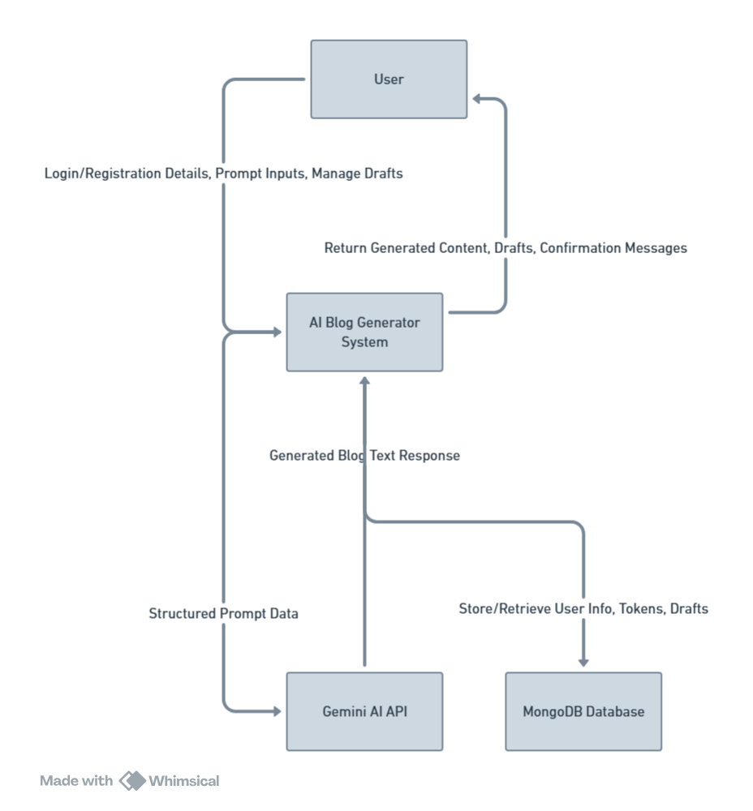

LEVEL 1
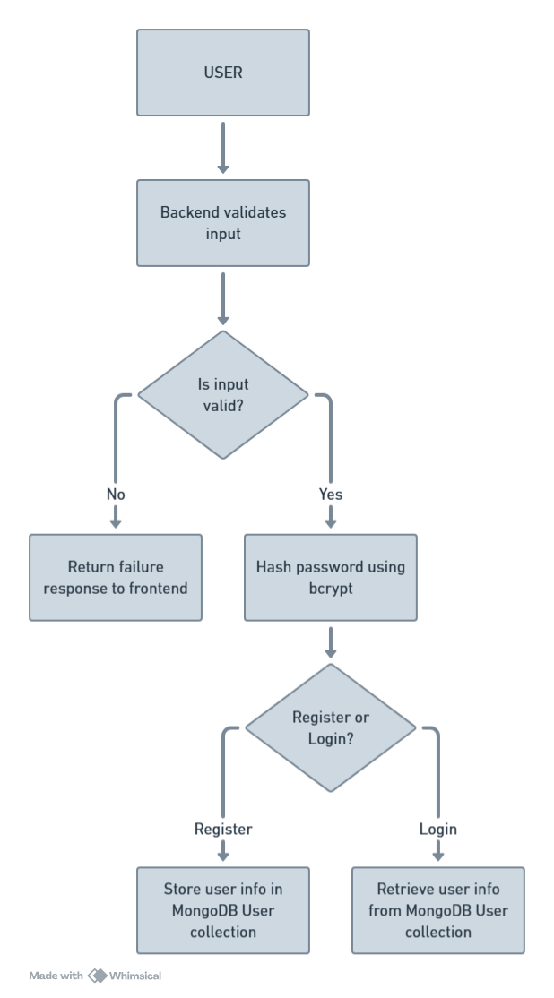

ER DIAGRAM
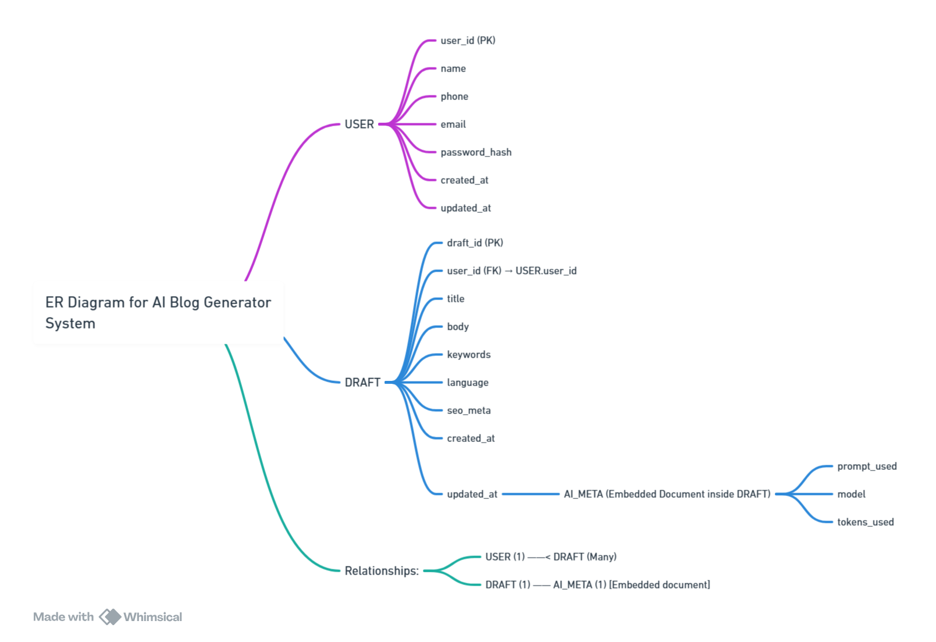

SYSTEM TESTING
System testing is a crucial phase in the software development life cycle where the integrated system is tested as a whole. The main objective of system testing is to evaluate the end-to-end functionality of the AI Blog Generator application and ensure that it meets the specified requirements. It verifies that all modules — such as user authentication, AI-based content generation, draft management, and database connectivity — work seamlessly together without errors or inconsistencies.
This stage is performed after unit and integration testing and focuses on the validation of both functional and non-functional requirements. Since this system involves backend APIs, AI service integration (Gemini API), and a React frontend, testing ensures the smooth interaction of all these components.

Objectives of System Testing
- To ensure that the system performs as intended under all conditions.
- To verify the correctness of data flow between frontend, backend, and database.
- To confirm that the AI-generated blogs are stored, retrieved, and displayed correctly.
- To ensure that all system modules (user registration, login, content generation, drafts, etc.) are fully integrated and functional.
- To check the robustness, reliability, and performance of the system under load.
- To validate that the system adheres to all security and usability standards.

Testing Strategy
The testing of the AI Blog Generator is divided into the following stages:
- Unit Testing
  - Conducted on individual modules such as user registration, login, and token verification.
  - Used Jest and Mocha for API-level testing.
  - Each function was tested to ensure proper input validation and expected output generation.
- Integration Testing
  - Verified communication between frontend and backend components.
  - Tested REST API routes such as /api/auth/register, /api/auth/login, /api/drafts, and /api/generate.
  - Ensured that authentication tokens (JWT) were correctly validated by middleware before data access.
- System Testing
  - Performed on the entire system as a whole.
  - Focused on workflow: user registration → login → AI blog generation → saving drafts → retrieving drafts.
  - Confirmed that all data was properly stored in MongoDB and returned correctly via API calls.
- User Interface Testing
  - Verified that all pages render correctly (Register, Login, Dashboard, Editor, Saved Drafts).
  - Checked input validations, error alerts, and button responses.
  - Ensured proper responsiveness on desktop and mobile screens.
- Performance Testing
  - Evaluated API response times and load handling during multiple simultaneous requests.
  - Ensured that blog generation requests to the AI model did not slow down the frontend experience.
  - Used Postman and JMeter for endpoint stress testing.
- Security Testing
  - Checked that user passwords were hashed using bcrypt.
  - Ensured that JWT tokens expired after the defined time limit (7 days).
  - Verified that unauthorized users could not access protected routes like /api/drafts or /api/save.
- Acceptance Testing
  - Conducted with end users to verify that the system met their requirements.
  - Ensured that blog generation was accurate, fast, and editable.
  - Validated the usability of the interface and the accuracy of AI content generation.

Test Cases Summary
Test Case ID | Module | Description | Expected Result | Status
TC001 | Register | Verify all fields are mandatory | Proper error message when empty | ✅ Passed
TC002 | Login | Validate correct email/password combination | Login success and token generated | ✅ Passed
TC003 | Generate Blog | Check AI content generation via Gemini API | Blog text generated successfully | ✅ Passed
TC004 | Save Draft | Validate if draft saves under the logged-in user | Draft stored in MongoDB | ✅ Passed
TC005 | Fetch Drafts | Ensure drafts load only for authenticated users | Drafts retrieved correctly | ✅ Passed
TC006 | Unauthorized Access | Try fetching drafts without token | Returns “unauthenticated” | ✅ Passed
TC007 | Input Validation | Enter invalid email or short password | Shows validation error | ✅ Passed
TC008 | Performance | Send multiple simultaneous blog generation requests | API handles load properly | ✅ Passed

Testing Tools Used
- Postman – for manual API testing and verification.
- Jest / Mocha – for unit and integration testing of backend logic.
- MongoDB Compass – for verifying database entries after each operation.
- React Developer Tools – for debugging UI component behavior.
- JMeter – for performance and load testing.

Results and Observations
- All core functionalities worked as expected after integration.
- The JWT authentication middleware successfully protected private routes.
- AI-generated content through the Gemini API responded within acceptable time limits.
- No major UI rendering errors or API mismatches were observed.
- The system was found to be stable, secure, and reliable for end users.

CONCLUSION
The AI Blog Generator project successfully integrates modern web technologies and artificial intelligence to simplify and accelerate the content creation process. The system demonstrates how AI can be effectively utilized to generate high-quality, human-like blog articles with minimal user input, thereby bridging the gap between automation and creativity.
Through the use of the MERN stack (MongoDB, Express.js, React.js, Node.js) combined with Google Gemini API, the project delivers a robust, scalable, and interactive application that allows users to generate, edit, and manage AI-written blogs in real-time. The system provides essential features such as secure authentication using JWT, dynamic content generation, draft storage, and intuitive editing through a Quill-based text editor.
From a technical perspective, the project achieves the goal of seamless integration between frontend and backend systems, supported by an intelligent middleware layer that ensures security and session management. The application’s architecture was designed for modularity and extensibility, allowing future enhancements like SEO optimization, keyword analysis, and multi-language generation.
System testing confirmed the reliability and performance of the platform. Each functional module — user registration, login, AI content generation, and draft management — was validated individually and as part of the integrated workflow. The successful test outcomes prove that the system meets both the functional and non-functional requirements specified during the design phase.
On a broader level, this project illustrates the transformative potential of artificial intelligence in the field of content creation and digital marketing. It demonstrates how AI can assist writers, students, and professionals in generating structured and contextually relevant articles within seconds, improving productivity and creativity.
In conclusion, the AI Blog Generator stands as a practical and innovative solution that combines the intelligence of machine learning with the accessibility of modern web technologies. It not only showcases the effectiveness of the MERN framework but also highlights the growing importance of AI in automating creative tasks. The project lays a solid foundation for further research and enhancement in AI-powered writing assistants, representing a meaningful step toward the future of intelligent content generation systems.

FUTURE SCOPE
The development of the AI Blog Generator marks a significant step toward integrating artificial intelligence with web-based content creation. However, technology continues to evolve rapidly, and there is substantial potential for further enhancement and innovation in this system. The following future improvements and extensions can be considered to make the application more intelligent, user-friendly, and commercially viable:
1. Advanced AI Capabilities
Future versions of the system can integrate more advanced large language models (LLMs) such as Gemini Ultra, GPT-5, or Claude to generate content with improved coherence, creativity, and contextual understanding. These models can help produce more personalized writing styles and support industry-specific blog content such as technology, healthcare, travel, and finance.
2. Multilingual and Localization Support
Currently, the system primarily generates content in English. Expanding support for multiple languages like Tamil, Hindi, French, Spanish, or Japanese would make the platform more inclusive and globally accessible. Localization features such as cultural tone adjustment, regional vocabulary, and grammar adaptation can also be introduced.
3. SEO and Readability Enhancements
Incorporating built-in Search Engine Optimization (SEO) tools would allow users to optimize their AI-generated blogs for better search visibility. Features like keyword density analysis, readability scoring, and meta-description generation could make the application highly useful for content marketers and digital creators.
4. Voice-to-Text Blog Creation
With the growing demand for hands-free content creation, future updates could include speech recognition and voice-to-text capabilities, enabling users to dictate their ideas and instantly convert them into structured blog drafts using AI.
5. Image and Media Integration
To enrich blogs visually, the system could integrate AI image generation (e.g., DALL-E or Stable Diffusion) for creating custom feature images or infographics based on the blog topic. Additionally, media embedding features like videos, charts, and interactive graphics can be included.
6. AI-Powered Plagiarism Detection and Paraphrasing
Implementing real-time plagiarism detection and AI-based paraphrasing tools will ensure the originality and uniqueness of generated content. This would help users maintain professional writing standards and avoid duplication.
7. Collaboration and Multi-User Environment
Introducing a multi-user collaboration module would enable teams to work together on the same document, leave comments, and make live edits — similar to Google Docs. This feature would be particularly beneficial for agencies and academic institutions.
8. Cloud Integration and Deployment
Deploying the platform on cloud services like AWS, Google Cloud, or Azure would enhance scalability, reliability, and performance. It would also allow for secure backups, faster load times, and global accessibility for remote users.
9. Mobile Application Development
Creating a mobile version of the AI Blog Generator using React Native or Flutter can provide users with the flexibility to generate and edit blogs directly from their smartphones or tablets, thereby improving usability and accessibility.
10. Analytics and Performance Insights
Future iterations can include an analytics dashboard that tracks user activity, content engagement metrics, word count, time saved, and AI model performance. This would help in continuous system improvement and give valuable insights to users about their writing patterns.

BIBLIOGRAPHY
• Douglas Crockford, JavaScript: The Good Parts, O’Reilly Media, 2008.
– A fundamental reference on the JavaScript language used in both the frontend (React) and backend (Node.js) components of the system.
• Ethan Brown, Web Development with Node and Express: Leveraging the JavaScript Stack, O’Reilly Media, 2nd Edition, 2019.
– Provided essential insights into setting up backend servers and RESTful API development for scalable web applications.
• Alex Banks and Eve Porcello, Learning React: Modern Patterns for Developing React Apps, O’Reilly Media, 3rd Edition, 2020.
– Served as a primary guide for building interactive user interfaces and managing frontend components effectively.
• MongoDB Inc., MongoDB Documentation, https://www.mongodb.com/docs/
– Official documentation used for understanding NoSQL data modeling, schema design, and efficient querying in MongoDB Atlas.
• Express.js Documentation, https://expressjs.com/
– Used extensively for designing backend routing, middleware, and API endpoints in the Node.js environment.
• React Documentation, Meta Platforms Inc., https://react.dev/
– Primary source for frontend component design, hooks, and rendering optimizations.
• Google AI, Gemini API Documentation, https://ai.google.dev/
– Used to understand prompt structuring, AI content generation, and safe response handling using Gemini 1.5 / 2.5 APIs.
• React-Quill and React-Quill-New Documentation, https://github.com/zenoamaro/react-quill
– Reference for implementing rich text editing and sanitization within the editor interface.
• JWT (JSON Web Token) Specification, https://jwt.io/introduction
– Used for implementing secure authentication and authorization through token-based identity verification.
• BCryptJS GitHub Repository, https://github.com/dcodeIO/bcrypt.js
– Reference for password hashing and comparison methods to ensure secure user authentication.
• MDN Web Docs, Mozilla Foundation, https://developer.mozilla.org/
– Used throughout the development process for understanding JavaScript, HTML, and HTTP protocol standards.
• Tailwind CSS Documentation, https://tailwindcss.com/docs
– Referenced for creating responsive, modern, and visually clean frontend UI components.
• JSON Specification, ECMA International, 2013.
– For understanding structured data exchange between frontend and backend via REST APIs.
• GitHub and Stack Overflow Developer Communities, 2024–2025.
– Provided solutions for debugging, optimizing React component states, backend routing, and deployment configurations.
• OpenAI Research and Gemini AI Model Papers, Google DeepMind Publications (2023–2025).
– Used as theoretical background for understanding large language models and AI-driven content generation.

